## Task-1: Complete the data tables.

## Task -2: Do the K-mapping for the required design in your notebook and attach their pictures here.

## Task -3: Design the required BCD to Excess-3 converters in the logisim and attach their screenshots below.

## Experimental Data

|  |  |  |  |  |  |  |  |  |
| --- | --- | --- | --- | --- | --- | --- | --- | --- |
| **Decimal Digit** | **Binary Coded Decimal (BCD)** | | | | **Excess-3** | | | |
| W | X | Y | Z | A | B | C | D |
| **0** | 0 | 0 | 0 | 0 | 0 | 0 | 1 | 1 |
| **1** | 0 | 0 | 0 | 1 | 0 | 1 | 0 | 0 |
| **2** | 0 | 0 | 1 | 0 | 0 | 1 | 0 | 1 |
| **3** | 0 | 0 | 1 | 1 | 0 | 1 | 1 | 0 |
| **4** | 0 | 1 | 0 | 0 | 0 | 1 | 1 | 1 |
| **5** | 0 | 1 | 0 | 1 | 1 | 0 | 0 | 0 |
| **6** | 0 | 1 | 1 | 0 | 1 | 0 | 0 | 1 |
| **7** | 0 | 1 | 1 | 1 | 1 | 0 | 1 | 0 |
| **8** | 1 | 0 | 0 | 0 | 1 | 0 | 1 | 1 |
| **9** | 1 | 0 | 0 | 1 | 1 | 1 | 0 | 0 |

**Table F1: Truth table - BCD to Excess-3**

|  |  |  |  |
| --- | --- | --- | --- |
| **Number of inputs bits:** | 4 | **Input variables:** | W,X,Y,Z |
| **Number of outputs bits:** | 4 | **Output variables:** | A,B,C,D |

**Table F2: System analysis**

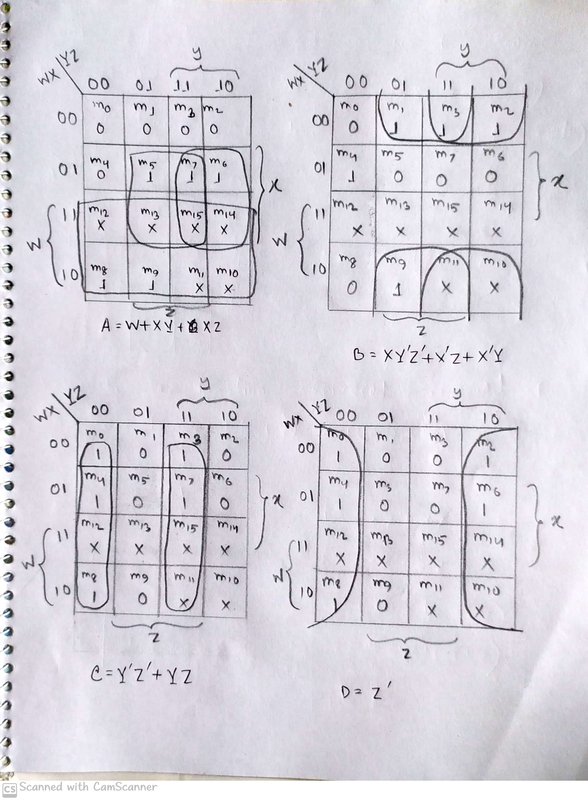

## Figure F1: K-Maps

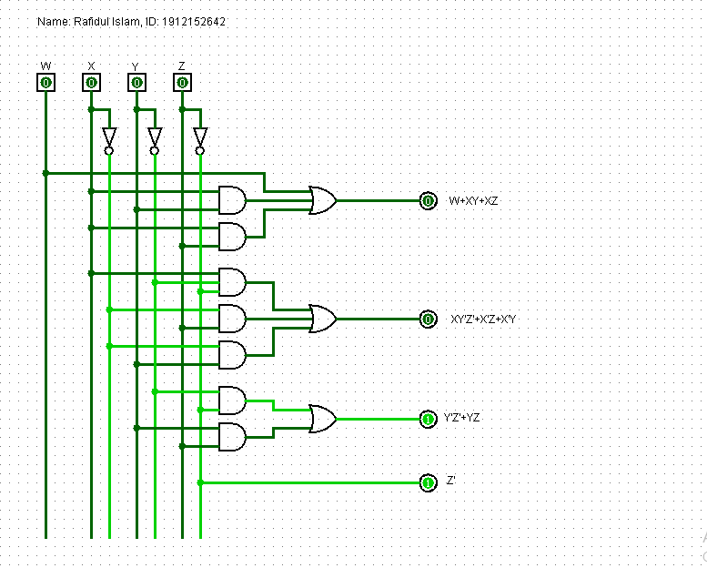

**Figure F2: Minimal 1st canonical circuit of BCD to Excess-3 converter**

**Figure F3: Minimal universal gate implementation of BCD to Excess-3 converter**